**Assignment 1**

RattanakVichboth, Heng

American University of Phnom Penh

INFO 653 001 – Web Development III

Prof, BUNTOUN Monyrath

08 February 2025

Table of Contents

I. **Introduction** 3

**II.** **Program Overview** 3

**III.** **Code Explanation** 3

**A.** **Setting Up** 3

**B.** **User Input** 3

**C.** **Operation Functions** 4

**D.** **Main and Control Flow** 5

**IV.** **Program output** 8

**A.** **Startup Menu** 8

**B.** **Result Displays** 9

**V.** **Conclusion** 9

**A.** **Key findings** 9

**B.** **Limitations** 10

**C.** **Future Research and Improvement** 10

**D.** **Code submission** 10

VI. References 11

# **Introduction**

This report examines the functionality of a basic math calculation using a program written in JavaScript programming language. This program provides extensive basic math calculations, including addition (+), subtraction (-), multiplication (*), and division (*). Additionally, it will include programming concepts such as conditional statements (using switch-case), loops (while and for), jumping statements (break and continue), and error handling using try/catch.

# **Program Overview**

The program is structured with:

* User Input: Using Node.js function (readline) to get the user input.
* Calculation: Based on the user’s selected choice, it will perform a basic math calculation neither addition, subtraction, multiplication, and division.
* Code Flow: The program continues to run with a loop of (while) to allow the user to use multiple operations until the user decides to exit and break the loop.
* Error Handling: Using try/catch to ensure that the user won’t input any non-numeric and division-by-zero. If so, the program will show an error message.

# **Code Explanation**

## **Setting Up**

The code begins with importing all necessary packages or libraries (readline).

## **User Input**

Define questions and get user responses to continue the program.

## **Operation Functions**

Define separate 4 math functions by using an array of numbers and for loop.

## **Main and Control Flow**

Create a main function to control the flow of code with a while loop, switch-case, and try/catch error handling.

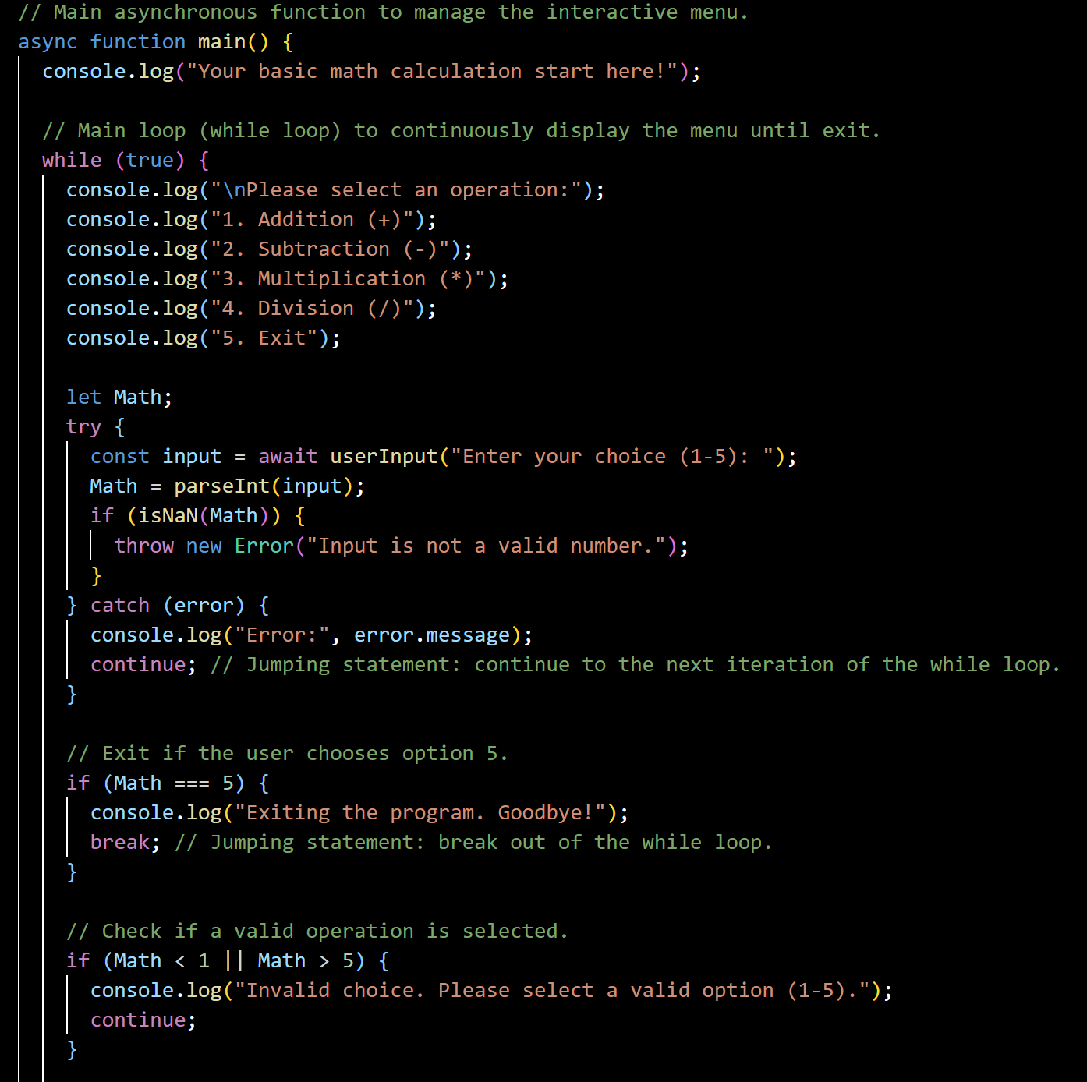

# **Program output**

## **Startup Menu**

## **Result Displays**

# **Conclusion**

## **Key findings**

* + Basic math calculation using JavaScript.
  + Able to use multiple times until exit.
  + A combination of while and for loop keeps the program continuously working.
  + Error handling did not allow any non-numeric and other unnecessary input.

## **Limitations**

* + Can’t perform other operations besides addition, subtraction, multiplication, and division.
  + Lack of UI, the program running on the backend (terminal).
  + Limited error handling, the program cannot let the user reinput after getting an error unless they rerun the program.

## **Future Research and Improvement**

* + Improve advanced mathematical operation.
  + Developing frameworks for better user-friendly interfaces.

## **Code submission**

# References

Nodejs(.n.d): Run javascript everywhere.

Retrieved from: <https://nodejs.org/en>

MozillaDeveloperNetwork(.n.d): Control flow and error handling.

Retrieved from: <https://developer.mozilla.org/enUS/docs/Web/JavaScript/Guide/Control_flow_and_error_handling>

W3School(.n.d): Javascript tutorial.

Retrieved from: <https://www.w3schools.com/js/>